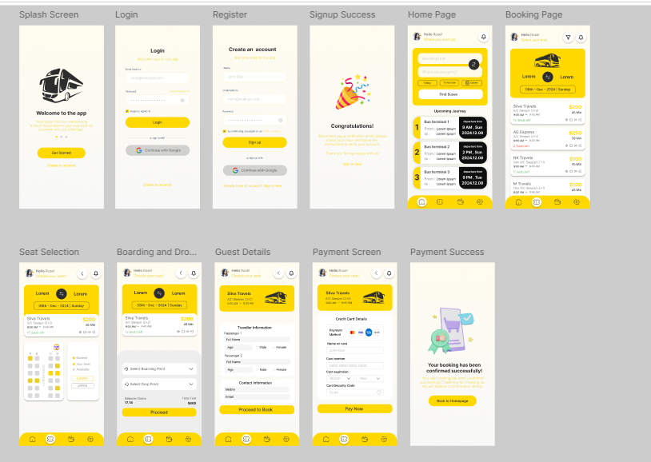
EX .2.BUS TICKET BOOKING PROTOTYPE

